Final Project:
Black Friday Purchase sales prediction

Table of Contents
- Introduction, with research question
- Data Appraisal
- Techniques (a.k.a. Methods)
- Evaluation
- Model
- Results

Introduction, with research question
A retail company “ABC Private Limited” wants to understand the customer purchase behavior (specifically, purchase amount) against various products of different categories. They have shared purchase summary of various customers for selected high-volume products from last month.
They want to build a model to predict the purchase amount of customer against various products which will help them to create personalized offer for customers against different products.
Perhaps one of the most obvious applications of Machine Learning in retail is predicting how much a customer is likely to spend at a store. Such predictor has a clear commercial value to the store owners as it would help with their financial planning, inventory management, marketing, and advertising.
Using this information, a machine learning model will be built that will predict the purchase amount based on the customer’s demographics and the categories of the products. In the end, ABC Private Unlimited will have information that they can use to offer customers products that will be appropriate for them.

Data Appraisal
The dataset we will be working with in this tutorial is Black Friday Sales. This particular dataset contains the Sales details of a retail store. we will analyze various features in the dataset and go through the complete data analysis process. We have been provided with various information about customer demographics (age, gender, marital status, city type, stay in current city) and product details (product id and product category). The data set has 11 variables and more than 2 lakhs purchase records.
The first step in exploring the data is loading the libraries that will be used for analysis. Next the data was stored in the variable black_friday. Inspecting the data reveals that every variable other than Purchase is a categorical variable. However, there are some columns that are stored as numerical data. The columns that needed changing were Marital_Status, Occupation, User_ID, Product_Category_1, Product_Category_2 and Product_Category_3. So, these columns were changed to factor variables.
If we analyze it individually, we see that we do not have any information regarding the stores. Moreover, there is some information related to the customer such as age group, sex, occupation and marital status. On the other hand, we have data on the city’s size and how many years the customer has lived in it whereas on the product’s side there is only information regarding the categories and the amount spent. It is my belief that Gender, Age, City_Category, Product_Category_1 are the predictors that will influence more the amount spent by a customer on this day.
The objective is to predict the Purchase field given all the other features. Most of the features are self-explanatory.
The take away messages from data set are:
- There is a bit more than half a million rows in this dataset.
- Almost all columns represent categorical features
- Product Category 2 &3 had a lot of missing values, now represented as category 0
- It might be useful to represent the Stay_In_Current_City_Years category numerically rather than categorically.
- There is a lot of room for experimentation with feature crossing. e.g. Age X Marital_Status, or Gender X Occupation
- There are 5891 and 3623 distinct User and Product IDs respectively. So both features might benefit from embeddings.
Below is the data dictionary:
- User_ID - User ID
- Product_ID – Product ID
- Gender – Use gender
- Age – Age in bins
- Occupation – Occupation (Masked for better data usage)
- City_Category – Category of the city
- Stay_In_Current_City_Years – Number of years stay in current city
- Marital_Status – Marriage status
- Product_Category_1 – Product category (target variable)
- Product_Category_2 – Product may belong to another category also
- Product_Category_3 – purchase amount
Techniques (a.k.a. Methods)
This report uses machine learning in order to build a prediction model that will predict a customer’s purchase amount. The first step to building this model is removing the User_ID and Product_ID columns. These columns were removed because they are variables that have zero variance. Each Product_ID and each User_ID will be particular to the customer or product.
After these near zero variance variables were removed, a sample was selected from the data. This sample was selected because this dataset is large. Its size may cause trouble when building a machine learning model. Fortunately, a large sample of the data should be enough to represent the data accurately and to build a machine learning model. The sample that was selected was selected randomly. The sample size 10000 records from the available data. Once the sample is selected, the next step in building the model can be performed.
Next the sampled data was partitioned. First 5000 of the sample was selected randomly to be the train set. The train set is the data that will be used to build the algorithm. The other 5000 of the sample was assigned to the test set. The test set will be used to test the accuracy of the model.
Once the sample is partitioned, a list of machine learning algorithms using different methods is compiled.
To get an idea of the distribution of numerical variables, histograms are an excellent starting point. Let’s begin by generating one for Purchase, our target variable.
plt.style.use(‘fivethirtyeight’)
plt.figure(figsize=(12,7))
sns.distplot(train.Purchase, bins = 25)
plt.xlabel(“Amount spent in Purchase”)
plt.ylabel(“Number of Buyers”)
plt.title(“Purchase amount Distribution”)
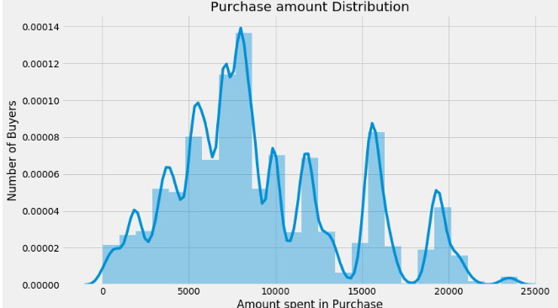
It seems like our target variable has an almost Gaussian distribution. Now that we’ve analyzed our target variable, let’s consider our predictors. Let’s start by seeing which of our features are numeric.
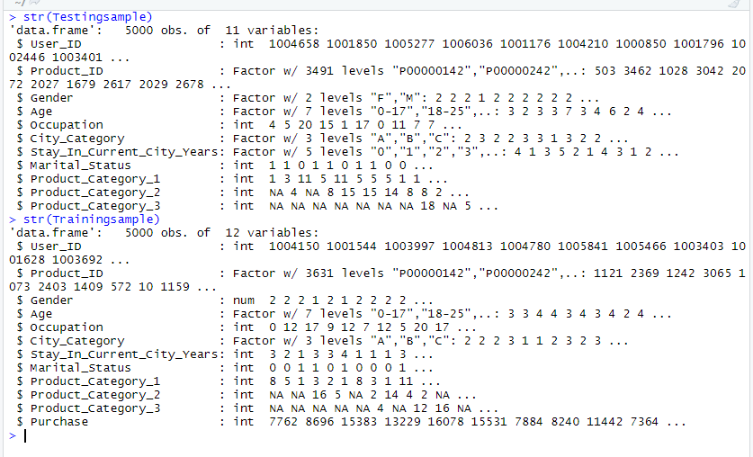
Let’s look at each variable:
- As seen in the beginning, Occupation has at least 20 different values. Since we do not know to each occupation each number corresponds, is difficult to make any analysis. Furthermore, it seems we have no alternative but to use since there is no way to reduce this number.
- There are more single people buying products on Black Friday than married people.
- Most of the buyers are males, but who spends more on each purchase.
- when we look at data, we can say most purchases are made by people between 18 to 45 years old.
- The tendency looks like the longest someone is living in that city the less prone they are to buy new things. Hence, if someone is new in town and needs a great number of new things for their house that they’ll take advantage of the low prices in Black Friday to purchase all the things needed.
- Although there are some occupations which have higher representations, it seems that the amount each user spends on average is more or less the same for all occupations. Of course, in the end, occupations with the highest representations will have the highest amounts of purchases.
- We had more single customers than married. However, on average an individual customer tends to spend the same amount independently if his/her is married or not. Again, if you had all the purchases the single group, since has a higher representation, will have the highest purchase values.

Let’s build a co-relation matrix and see how variables are related to each other.
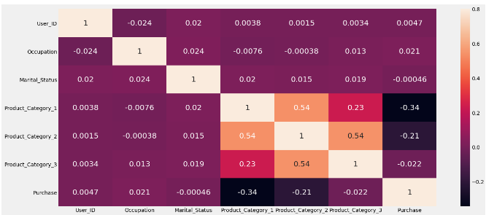
There seems to be no multicollinearity with our predictors which is a good thing, although there is some correlation among the product categories.With this we can say product_category_2 and product_category_3 can be disposed.
Now we will see what are the complications in processing the data:
- We will process the data in both training and test data set. Data processing is not static procedure. It completely depends on the data we are using. For this data we have below complications:
  - Product Category 2 &3 had a lot of missing values. We have to fill the gaps with the appropriate value if necessary.
  - It is useful to represent the Stay_In_Current_City_Years category numerically rather than categorically.
  - We are not going to predict purchase amount based on customer ID and product ID. So, we can eliminate this for better processing.
  - For better analysis, change the City_category names into A, B, C instead of full names.
During our EDA we were able to take some conclusions regarding our first assumptions and the available data:
Age: should be treated as numerical. It presents age groups.
City_Category: We can convert this to numerical as well, with dummy variables. Should take a look at the frequency of the values.
Occupation: It seems like it has at least 16 different values, should see frequency and try to decrease this value.
Gender: There are possibly two gender, we can make this binary/numeric.
Product_ID: Should see if the string “P” means something and if there are other values.
Stay_In_Current_City_Years: We should deal with the ‘+’ symbol.
Product_Category_2 and Product_Category_3: Have NaN values.
I worked on multiple supervised and un-supervised learning algorithms like linear regression, K-means, few decision tree algorithms. After looking at data and research question I feel linear regression is the correct model for this data set. At the same time, I would like to see how we can predict the purchase amount using neural network for structured data.

Evaluate
Let’s see how can we evaluate linear regression and neural network models.
Validation and Evaluation of a Data Science Model provides more color to our hypothesis and helps evaluate different models that would provide better results against our data. These are the metrics that help us evaluate our models.
There are three main errors (metrics) used to evaluate models, Mean absolute error, Mean Squared error and R2 score.
Let’s take an example where we have some points. We have a line that fits those points. When we do a summation of the absolute value distance from the points to the line, we get Mean absolute error. The problem with this metric is that it is not differentiable.
Mean Squared Error solves differentiability problem of the MAE. Consider the same diagram above. We have a line that fits those points. When we do a summation of the square of distances from the points to the line, we get Mean squared error.
R2 score answers the question that if this simple model has a larger error than the linear regression model. However, it terms of metrics the answer we need is how much larger. The R2 score answers this question. R2 score is 1 — (Error from Linear Regression Model/Simple average model).
Best possible score is 1.0 and it can be negative (because the model can be arbitrarily worse). A constant model that always predicts the expected value of y, disregarding the input features, would get a R² score of 0.0.

Model evaluation leads a Data Scientist in the right direction to select or tune an appropriate model. In a Data Science Interviews, it tests the fundamentals of candidates in the same way. In any interview, knowing these values and terms for the problems being discussed is table stakes.
Model
Before knowing what is linear regression, let us get ourselves accustomed to regression. Regression is a method of modelling a target value based on independent predictors. This method is mostly used for forecasting and finding out cause and effect relationship between variables. Regression techniques mostly differ based on the number of independent variables and the type of relationship between the independent and dependent variables.
Simple linear regression is a type of regression analysis where the number of independent variables is one and there is a linear relationship between the independent and dependent variable. When there is a single input variable (x), the method is referred to as simple linear regression. When there are multiple input variables, literature from statistics often refers to the method as multiple linear regression.
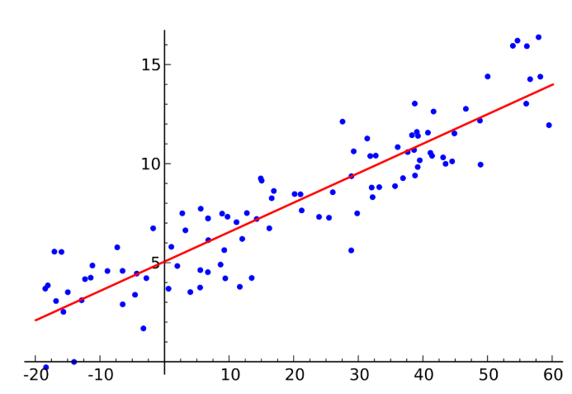
The red line in the above graph is referred to as the best fit straight line. Based on the given data points, we try to plot a line that models the points the best.
Now we will see how neural network algorithm works:
Artificial Neural Networks (ANN) have many different coefficients, which it can optimize. Hence, it can handle much more variability as compared to traditional models. Deep Neural networks have been proven to be very effective in performing tasks that involve classification and prediction based on the complexity of the data. Most importantly, it is highly useful in situations where the input data has a complex relationship with the target variable and the dimensions of the input data is very high.
ANNs can generalize — After learning from the initial inputs and their relationships, it can infer unseen relationships on unseen data as well, thus making the model generalize and predict on unseen data.
Neural networks help us cluster and classify. You can think of them as a clustering and classification layer on top of the data.
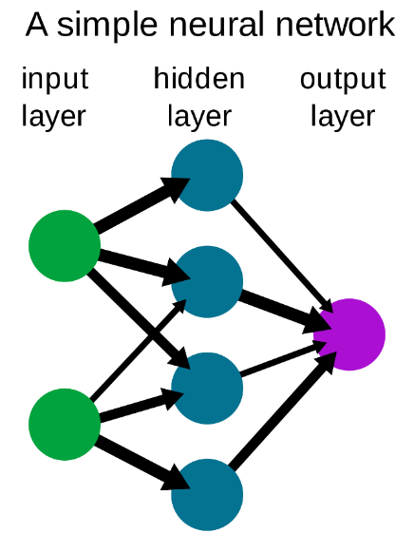
Neural networks works best for pattern recognition which in return unstructred data. Today, neural networks are used for solving many business problems such as sales forecasting, customer research, data validation, and risk management. For example, at Statsbot we apply neural networks for time-series predictions, anomaly detection in data, and natural language understanding.
- It would be convenient to explain the prediction of a model if the model representation was similar to a decision tree which takes into consideration a series of variables and provides a way forward or a decision based on them. There are many prediction algorithms available but we have to see which one bets fits for the data and the type of prediction.
- With this evaluation we can say that these model results will correctly fit with the data we have chosen. We are expecting the purchase amount of products depends on various categories. That’s the same will be the result of linear regression and neural networks. These algorithms are best to predict the values based on given input values.
Training data set has 11 variables named User_ID, Product_ID, Gender, Age, Occupation, City_Category, Stay_In_Current_City_Years, Marital_Status, Product_Category_1, Product_Category_2, Product_Category_3, Purchase Amount.
Testing data set has all variables except Purchase amount. Purchase amount depends on Gender, Age, Occupation, City_Category, Stay_In_Current_City_Years, Marital_Status, Product_Category_1.

Let’s look at over all steps involved in implementing linear regression model.
- Let’s load the data sets into R. We have more than 5 lakhs records so for best results we will consider 5000 records from each set.
- Check what is the data structure in both data sets.
- Multiple linear regression accepts only numeric data. So, lets convert all int, factorial variables into numeric data in both testing and training data sets.
- Sales amount is not dependent on user details or product Id. We have product category as a key to predict sales and product ID is not in need. So, we can ignore these columns from the data sets.
Few product categories have sub categories (product_category_2, product_category_3) and few don’t have sub categories. So, we can remove sub categories also. As these two doesn’t pay much importance towards sales amount.
- Now finally we have clear data with proper data types. So, we can now build the model. As I removed all unnecessary variables, I am considering target as “Purchase” and input as all remaining variables.
modellm <- lm(Purchase ~., Trainingsample)

I used R studio to develop the model. Please find the below screen shot from R after loading data and model creation.

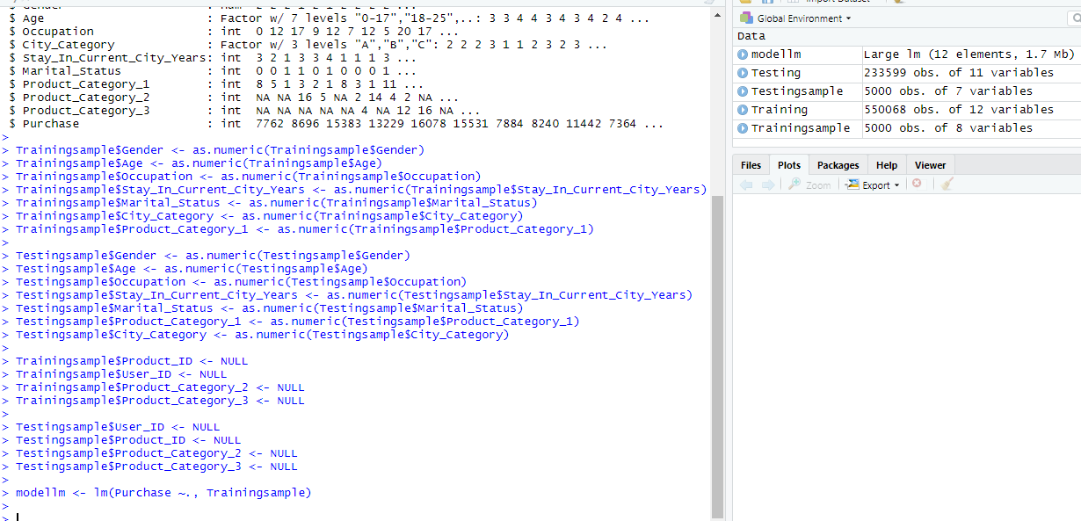
- Now we created model. Let’s predict the purchase amount for testing data set.
predictionlm <- predict(modellm,Testingsample,interval = 'confidence')

- Let’s print the predicted values. It shows three values. Best fit value, lower and upper limits too.
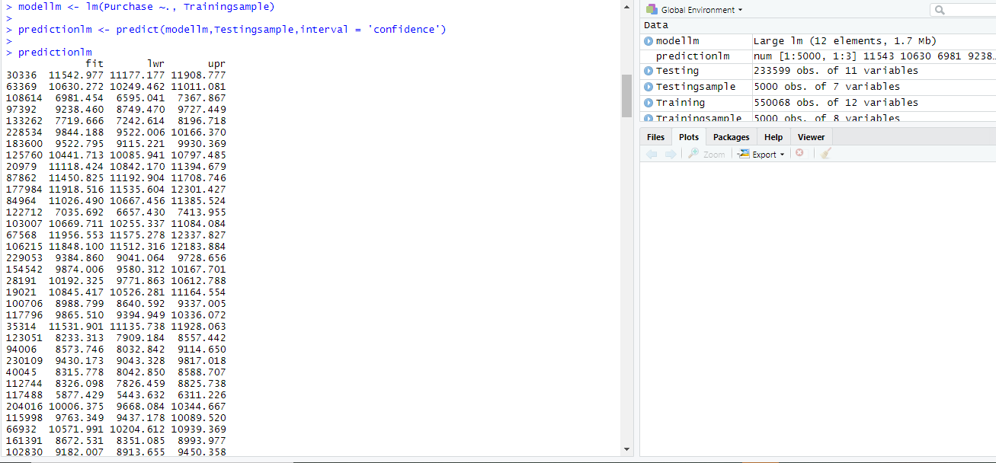

First on is the row number from test data set and remaining three values are prediction amounts. This means, in real time Purchase amount for the products available in those rows are ranging from these predicted values.
- Let’s plot the prediction and visualize the purchase amount with product category_1
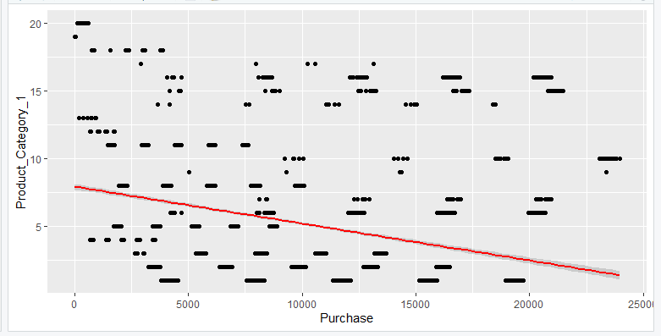

Results:
Are the results reasonable: In the end, it is always good to estimate our results by finding the mean absolute error (MAE) and mean squared error (MSE) of our predictions. After testing the prediction results against training data set we can say prediction results are very close by actual purchase amount.
When analyzing the data from the testing model, it is revealed that the Product_Category_1, Product_Category_2 and Product_Category_3 variables have new levels. These new variables will present a problem when making predictions. Therefore, the original models needed to be revisited and these variables were left as numeric variables after 0 was imputed for the missing values. Once the different models were used to make predictions, it is discovered that linear regression stack produced the best predictions. This model produced an RMSE of 3085.436. Therefore, it was the model used to make the final predictions for the testing dataset.
Conclusion:
There are a few conclusions that can be made using the analysis in this paper. The first conclusion is that even when broken down into different demographics, the median purchase made by customers does not fluctuate much. It didn’t matter if the group was male, female, young, old, married or unmarried, the median purchase by the customers hovered around $8000. However, some groups were more present than others. Males shopped more than females. The marital status 0 shopped more than the marital status 1. Unfortunately, which label mean married and which label means unmarried is unknown. Also, customers between the ages of 18 and 45 shopped the most. The age range 26-35 had the highest turnout. Additionally, people who only lived in their city for a year shopped a lot.
So, there are two different ways that ABC Private Limited could increase their sales. One way would be for them to advertise to groups that do not shop as often as the other groups. The thinking here is that no matter what, median purchase will not change much. However, these unrepresented groups could be represented more and increase purchases. The other option would be for ABC Private Limited to target the demographics that they know show up most often. The thinking here is that these customers produce the largest part of the customer base. Therefore, they would be the people most likely to shop in the store.

